- Do not edit/delete any heading or section with red text.
- Type /paste you answers in relevant sections (below Final Answer (in all questions , Approach (wherever required ) and Charts & tables (wherever required)) of the solution
- Link to submission guidelines
- Please note that submission not following the guidelines will not be accepted

OBJECTIVE QUESTIONS

Question 1: What is the total no. of tables present in the data?

Solution:

Final Answer (if any):
2 tables.
• Restaurant table: sheet 'Raw Data' (9,551 rows, one row per restaurant).
• Country lookup table: sheet 'country description' (15 rows: Country Code and Country Name).

Approach (if any):
• Opened the project workbook and listed the tables supplied with the data.
• 'Raw Data' is the main table. 'country description' is a small reference table that links to it through CountryCode (it is used later in Question 5).
• The other sheets (Cleaned Data, question sheets, Dashboard) were created by me for the analysis. They are outputs, not source tables, so they are not counted.

Charts & Tables (if any):
- Table / Chart Name:
Not applicable
- Description:
No separate table or chart is needed; the answer is a single value / short text.

Question 2: What is the total no. of attributes present in the data?

Solution:

Final Answer (if any):
20 attributes (columns) in the restaurant data.
RestaurantID, RestaurantName, CountryCode, City, Address, Locality, LocalityVerbose, Longitude, Latitude, Cuisines, Currency, Has_Table_booking, Has_Online_delivery, Is_delivering_now, Switch_to_order_menu, Price_range, Votes, Average_Cost_for_two, Rating, Datekey_Opening.

Approach (if any):
• Counted the column headings in row 1 of the original 'Raw Data' table (columns A to T) = 20.
• Columns added later for Question 5 (Country Name) and Question 12 (price with currency symbol), and the year/month/day columns created in Question 4, are my own helper columns, so they are not counted as original attributes.
• The separate 'country description' table has 2 attributes (Country Code and Country Name).

Charts & Tables (if any):
- Table / Chart Name:
Not applicable
- Description:
No separate table or chart is needed; the answer is a single value / short text.

Question 3: How many categorical columns are there in the data? [Search about categorical and continuous data, and try to answer this question]

Solution:

Final Answer (if any):
13 categorical columns (5 numeric columns, plus 1 identifier and 1 date column).
• Text categories (7): RestaurantName, City, Address, Locality, LocalityVerbose, Cuisines, Currency.
• Yes/No categories (4): Has_Table_booking, Has_Online_delivery, Is_delivering_now, Switch_to_order_menu.
• Coded categories (2): CountryCode (a code for a country) and Price_range (ordered categories 1 to 4).
• Continuous / numeric (5): Longitude, Latitude, Votes, Average_Cost_for_two, Rating.
• Identifier and date (2): RestaurantID and Datekey_Opening.

Approach (if any):
• Categorical data puts each record into a group or label (for example Yes/No, a city, a price band). Averages and sums of these values have no meaning. Continuous (numeric) data measures a quantity, so arithmetic on it is meaningful.
• Went through all 20 columns and asked: does adding or averaging this column make sense? CountryCode and Price_range are stored as numbers, but they are labels (country 1 is not 'less' than country 14; price range 3 is a band, not an amount), so they are treated as categorical.
• RestaurantID is only a unique key, and Datekey_Opening is a date, so neither is counted in either group. 13 + 5 + 2 = 20 columns, which matches Question 2.

Charts & Tables (if any):
- Table / Chart Name:
Not applicable
- Description:
No separate table or chart is needed; the answer is a single value / short text.

Question 4: The data consists of some inconsistent and missing values so ensure that the data used for further analysis is cleaned.

Solution:

Final Answer (if any):
The data was checked and cleaned; all 9,551 restaurants were kept for analysis.
• Duplicates: 0 found (RestaurantID is unique), so no rows were removed.
• Missing values: 9 blanks, all in Cuisines (all USA restaurants, none in the suggested countries).
• Inconsistent format: Datekey_Opening was stored as text (for example 2013_9_21); it was split into numeric year, month and day.
• Other data-quality points flagged: zero costs (18 rows), placeholder ratings of 1.0 (2,148 rows), a mislabelled currency (Philippines) and text-encoding errors in some names.

Approach (if any):
• Duplicates: checked RestaurantID (and the name + address combination) for repeats. None found.
• Missing values: counted blanks in every column. Only Cuisines had blanks (9 rows). I left them blank rather than inventing a value; they belong to the USA, so they do not affect any recommendation, and they are simply skipped in cuisine counts.
• Dates: Datekey_Opening came as text in the form year_month_day. I split it into three numeric columns (year, month and day, in columns T, U and V of Cleaned Data). This makes year-wise counts, the Year slicer and the 2017-2018 'new restaurant' flag possible.
• Value checks: Price_range only holds 1 to 4; Rating lies between 1.0 and 4.9; Votes are never negative; all Yes/No columns contain only Yes or No.
• Flagged, not deleted: (a) 18 restaurants (9 India, 9 USA) show an average cost of 0; (b) 2,148 restaurants have a rating of exactly 1.0, and 1,094 of these have 0 votes, so 1.0 looks like a placeholder for 'not yet rated' (2,139 of them are in India; none are in the suggested countries, so the recommendations are not affected); (c) the Philippines currency is labelled 'Botswana Pula(P)' in the data, but I treated it as the Philippine peso in the cost analysis (Question 4 of the subjective section); (d) a few names and the pound symbol contain encoding errors (for example 'ÛÁstanbul'), which I left as in the source.
• The 'Cleaned Data' sheet, which holds these fixes, is used for every later question.

Charts & Tables (if any):
- Table / Chart Name:
Sheet 'Cleaned Data' (9,551 rows)
- Description:
The cleaned table used for all analysis. It contains the original 20 columns plus Year/month/day, Country Name, price with currency symbol, and a new_2017_18 flag (1 if the restaurant opened in 2017 or later).

Question 5: Using the LookUp functions, fill up the countries in the original data using the country code.

Solution:

Final Answer (if any):
The Country Name column was filled for all 9,551 restaurants. Every country code matched, with no #N/A errors.
15 countries: India (8,652), USA (434), UK (80), UAE, Brazil and South Africa (60 each), New Zealand (40), Turkey (34), Australia (24), Philippines (22), Indonesia (21), Singapore, Qatar and Sri Lanka (20 each), Canada (4).

Approach (if any):
• Used a lookup function to match each restaurant's CountryCode against the 'country description' table.
• Formula in the Country Name column (row 2, filled down to row 9552):
=XLOOKUP(C2,'country description'!$A$2:$A$16,'country description'!$B$2:$B$16,0)
• XLOOKUP looks for the code in column A of the lookup table and returns the country from column B. It performs an exact match, so a wrong country can never be returned. (VLOOKUP with the last argument FALSE would give the same result.)
• Checked the result: no errors or blanks, and the country counts add up to 9,551.

Charts & Tables (if any):
- Table / Chart Name:
Sheet 'country description' and column 'Country Name (Objective Question 5)' in 'Cleaned Data'
- Description:
The lookup table (15 country codes and names) and the new column that it filled in.
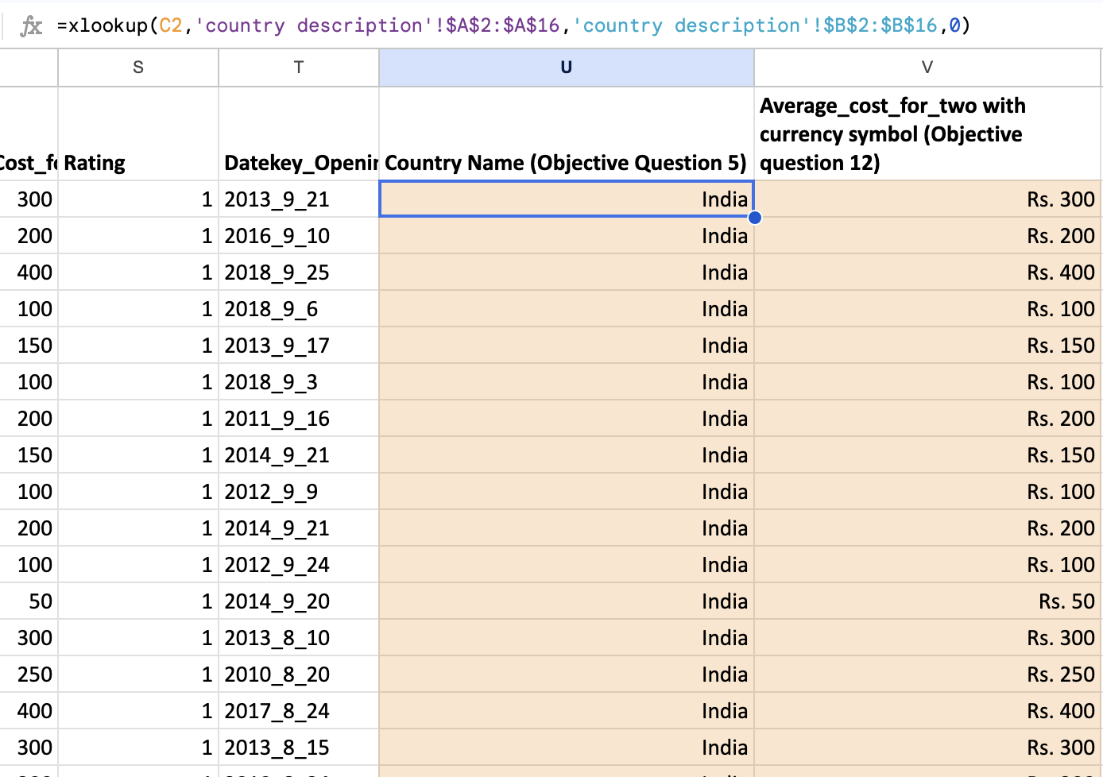

Question 6: Create a table to represent the number of restaurants opened in each country.

Solution:

Final Answer (if any):
Number of restaurants by country (total 9,551):
India 8,652 | United States of America 434 | United Kingdom 80 | United Arab Emirates 60 | Brazil 60 | South Africa 60 | New Zealand 40 | Turkey 34 | Australia 24 | Philippines 22 | Indonesia 21 | Singapore 20 | Qatar 20 | Sri Lanka 20 | Canada 4.

Approach (if any):
• Built a pivot table on 'Cleaned Data': Rows = Country Name, Values = COUNTA of RestaurantID, sorted from largest to smallest.
• Cross-check: the same counts with =COUNTIF(Country Name column, country); the total of the table equals 9,551.
• India alone holds 90.6% of the restaurants, so a bar chart of the table would be dominated by one bar; the table form is the clearest way to show the full list.

Charts & Tables (if any):
- Table / Chart Name:
Table: Restaurants by Country (sheet 'Q-6 I Objective')
- Description:
Pivot table showing how many restaurants are listed in each of the 15 countries.
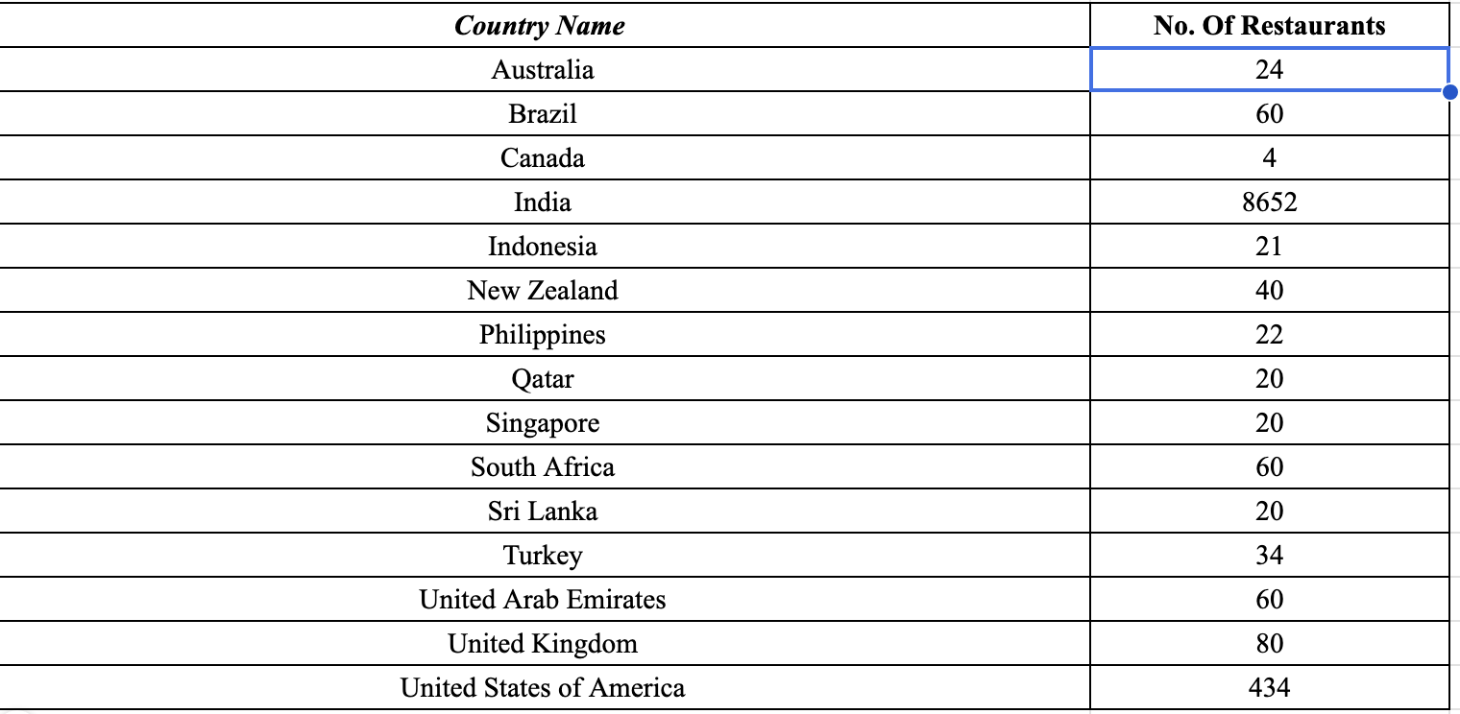

Question 7: Also, the management wants to look at the number of restaurants opened each year, so provide them with something here.

Solution:

Final Answer (if any):
Restaurants opened per year: 2010 - 1,080 | 2011 - 1,098 | 2012 - 1,022 | 2013 - 1,061 | 2014 - 1,051 | 2015 - 1,024 | 2016 - 1,027 | 2017 - 1,086 | 2018 - 1,102 (total 9,551).
Openings are steady at about 1,000 to 1,100 a year, with a low in 2012 and a high in 2018.

Approach (if any):
• Used the Year column created in Question 4 from Datekey_Opening.
• Pivot table: Rows = Year, Values = COUNTA of RestaurantID.
• Added a line chart so management can see the trend over time rather than only the numbers. The vertical axis starts at 0 so the small year-to-year changes are not exaggerated.

Charts & Tables (if any):
- Table / Chart Name:
Table and line chart: Restaurants Opened per Year (sheet 'Q-7 I Objective')
- Description:
Table of yearly openings and a line chart of the same figures (2010 to 2018).
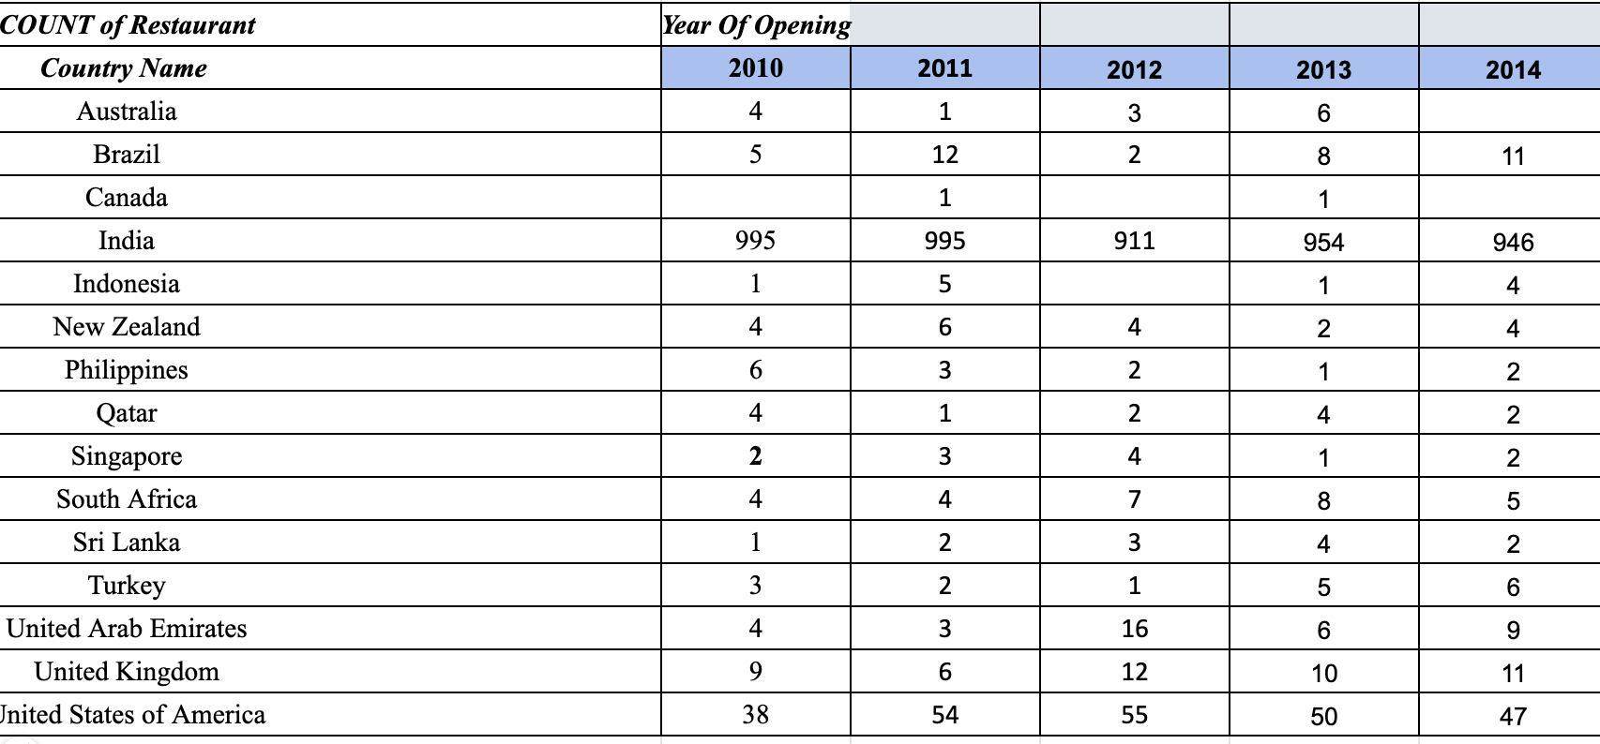

Question 8: What is the total number of restaurants in India in the price range of 4?

Solution:

Final Answer (if any):
388 restaurants.

Approach (if any):
• Counted restaurants where Country Name = India and Price_range = 4.
• Formula: =COUNTIFS('Cleaned Data'!W:W,"India",'Cleaned Data'!P:P,4) = 388.
• Cross-check: filtering Country Name = India and Price_range = 4 shows the same 388 rows. (These 388 are 4.5% of India's 8,652 restaurants.)

Charts & Tables (if any):
- Table / Chart Name:
Not applicable
- Description:
No separate table or chart is needed; the answer is a single value / short text.

Question 9: What is the average number of voters for the restaurants in each country according to the data?

Solution:

Final Answer (if any):
Average votes per restaurant, by country:
Indonesia 772.1 | United Arab Emirates 493.5 | Turkey 431.5 | United States of America 428.2 | Philippines 407.4 | South Africa 315.2 | New Zealand 243.0 | United Kingdom 205.5 | Qatar 163.8 | Sri Lanka 146.5 | India 137.2 | Australia 111.4 | Canada 103.0 | Singapore 31.9 | Brazil 19.6.

Approach (if any):
• Pivot table on 'Cleaned Data': Rows = Country Name, Values = AVERAGE of Votes, sorted from highest to lowest. (Equivalent formula: =AVERAGEIFS(Votes, Country Name, country).)
• Votes show how many customers rated a restaurant, so the average is a measure of customer engagement in each country. It also feeds the demand part of the opportunity score used in the subjective section.

Charts & Tables (if any):
- Table / Chart Name:
Table: Average Votes by Country (sheet 'Q-9 I Objective')
- Description:
Pivot table with the average number of votes per restaurant for each country.
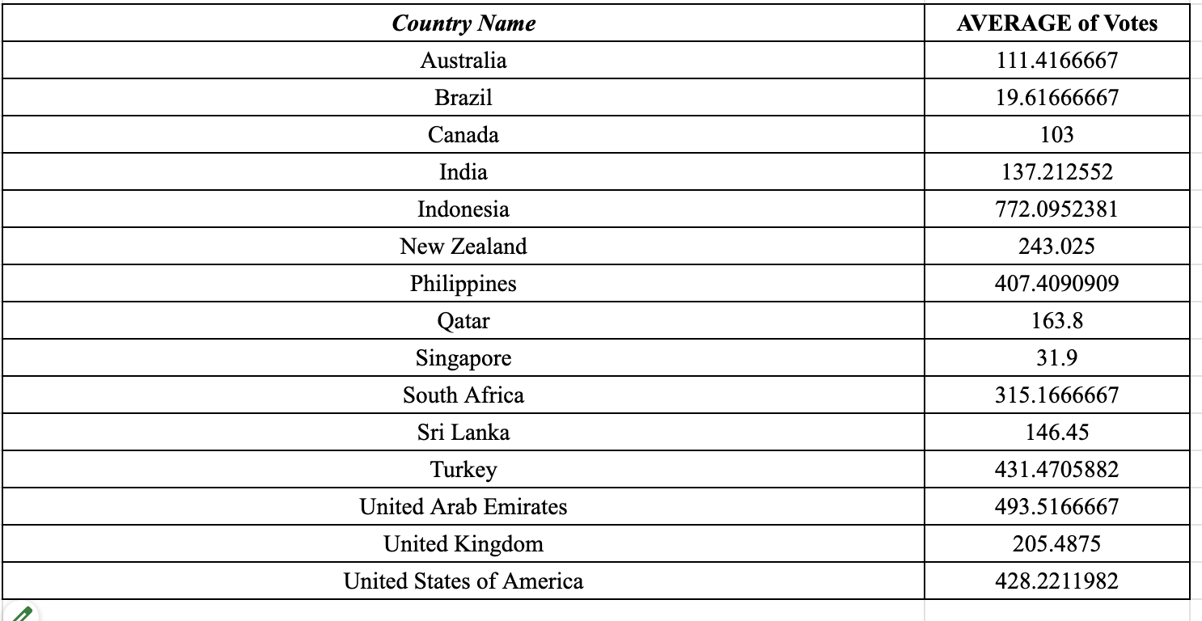

Question 10: Calculate the average rating for all the restaurants that have price_range < 4 and provide online delivery. Use only the “IF” function, Logical Operators, and Aggregation functions to solve this problem. [Note: Don’t use Conditional aggregation in this question.]

Solution:

Final Answer (if any):
Average rating = 3.27 (3.2738) across the 2,398 restaurants that have price_range < 4 and offer online delivery.

Approach (if any):
• The condition has two parts: Price_range < 4 AND Has_Online_delivery = "Yes". Only the IF function, logical operators and the SUM aggregation were used (no AVERAGEIFS / COUNTIFS).
• Array formula (average = sum of matching ratings divided by number of matching restaurants):
=ARRAYFORMULA(SUM(IF(('Cleaned Data'!P2:P9552<4)*('Cleaned Data'!M2:M9552="Yes"),'Cleaned Data'!S2:S9552,0))/SUM(IF(('Cleaned Data'!P2:P9552<4)*('Cleaned Data'!M2:M9552="Yes"),1,0)))
• The first SUM adds the ratings of matching restaurants; the second SUM counts them (2,398). In Excel, enter it as an array formula with Ctrl+Shift+Enter.

Charts & Tables (if any):
- Table / Chart Name:
Not applicable
- Description:
No separate table or chart is needed; the answer is a single value / short text.

Question 11: Using Conditional formatting highlight the rows of restaurants that are located in the countries or cities that you’ve suggested to the management for opening new restaurants.

Solution:

Final Answer (if any):
Rows are highlighted in 'Cleaned Data' for the suggested markets:
• Light red: all 77 restaurants in the three suggested countries (Indonesia 21, Philippines 22, Turkey 34).
• Dark red with white text: the 50 restaurants in the nine suggested cities (Jakarta, Tangerang, Bogor, Pasig City, Makati City, Pasay City, Mandaluyong City, Taguig City and Istanbul).

Approach (if any):
• Selected the whole table (A2:Y9552) and used Format > Conditional formatting with a custom formula, so the entire row is coloured, not just one cell.
• Rule 1 (listed first so it has priority), cities: =OR($D2="Tangerang",$D2="Jakarta",$D2="Bogor",$D2="Pasig City",$D2="Makati City",$D2="Pasay City",$D2="Mandaluyong City",$D2="Taguig City",ISNUMBER(SEARCH("stanbul",$D2)))
• Rule 2, countries: =OR($W2="Indonesia",$W2="Philippines",$W2="Turkey")
• The column letter is locked ($D, $W) and the row number is not, so each row is checked on its own. Istanbul is matched with a partial text search because the source data spells it 'ÛÁstanbul' (an encoding error).

Charts & Tables (if any):
- Table / Chart Name:
Sheet 'Cleaned Data' with conditional formatting applied
- Description:
Restaurants in the suggested countries are shaded light red, and those in the suggested cities dark red.
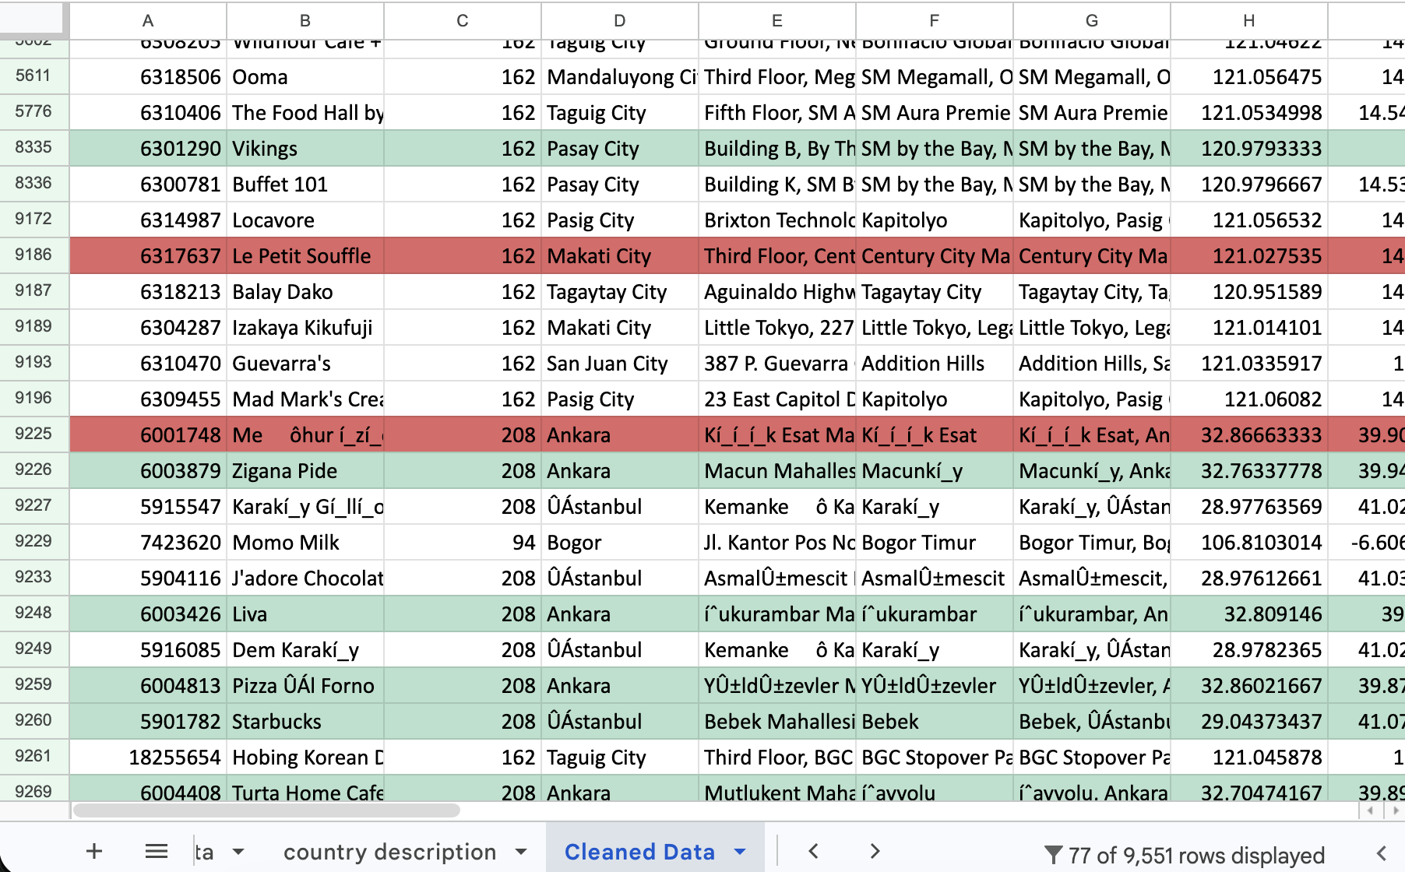

Question 12: Create a new customized price column that consists of the abbreviation/symbol of the currency along with the Average_cost_for_two value. [Use string operations to do this task]

Solution:

Final Answer (if any):
A new column, 'Average_cost_for_two with currency symbol', was created for all 9,551 restaurants. Examples: Rs. 300 (India), $ 50 (USA), AED 100 (UAE), R$ 100 (Brazil), TL 120 (Turkey), QR 150 (Qatar), IDR 70000 (Indonesia), LKR 1000 (Sri Lanka).

Approach (if any):
• The Currency column stores text such as 'Indian Rupees(Rs.)'. The symbol is the part between the brackets.
• Formula (row 2, filled down):
=MID(K2,FIND("(",K2)+1,LEN(K2)-FIND("(",K2)-1)&" "&R2
• FIND locates the opening bracket; MID takes the text after it up to (but not including) the closing bracket; & joins the symbol, a space and the Average_Cost_for_two value (column R).
• Known limitation: the pound sign is damaged in the source data ('Œ£'), so UK values appear as 'Œ£ 50'. I kept the source text as it is.

Charts & Tables (if any):
- Table / Chart Name:
Column 'Average_cost_for_two with currency symbol (Objective question 12)' in 'Cleaned Data'
- Description:
New text column that shows the currency symbol and the average cost for two together.
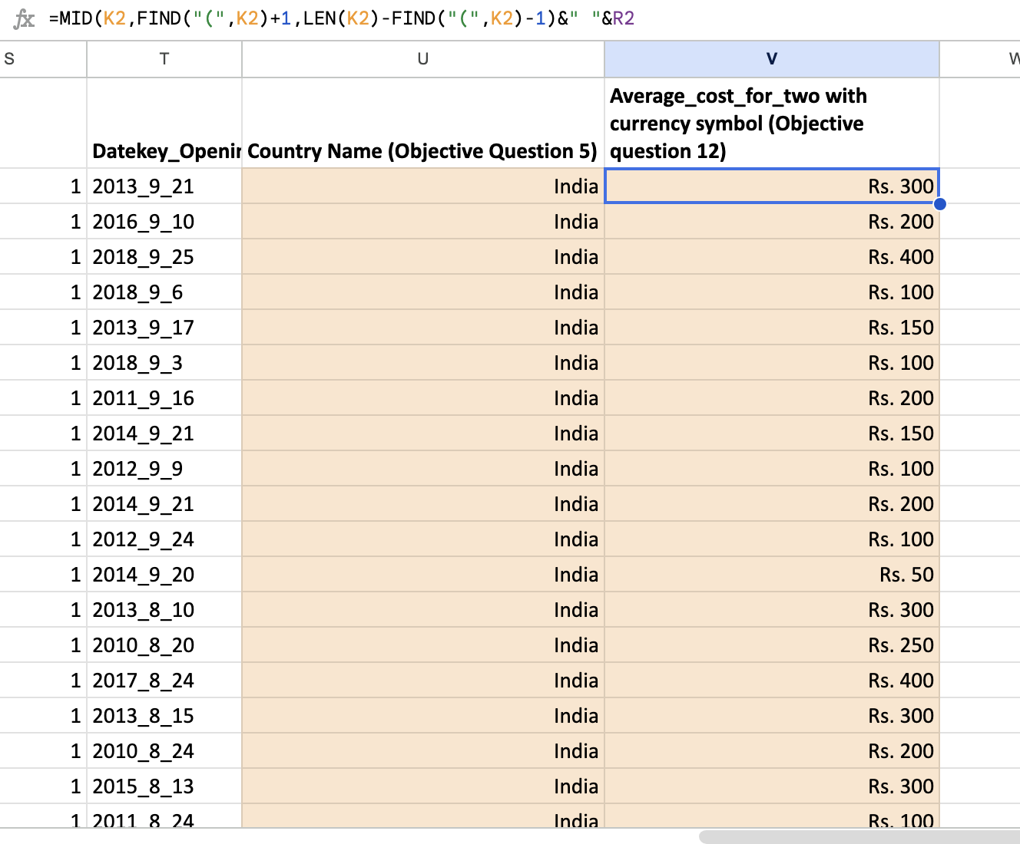

Question 13: How can you create an array formula in Excel or Google Sheets to count the number of restaurants listed that do not offer online delivery, are in the lowest price range, and have an average cost for two people less than or equal to 250 Indian Rupees?

Solution:

Final Answer (if any):
1,834 restaurants.

Approach (if any):
• Three conditions must all be true: Has_Online_delivery = "No", Price_range = 1 (the lowest range) and Average_Cost_for_two <= 250.
• Array formula: each condition gives TRUE/FALSE; multiplying them keeps only rows where all three are TRUE; SUM counts those rows:
=ARRAYFORMULA(SUM(IF(('Raw Data'!M2:M9552="No")*('Raw Data'!P2:P9552=1)*('Raw Data'!R2:R9552<=250),1,0)))
• The result is 1,834. The cost figure is used as stored in the data (<= 250). Because the costs are in each country's own currency, the count restricted to Indian-rupee restaurants only is 1,685; most of the 1,834 are Indian restaurants.
• In Excel, enter the formula with Ctrl+Shift+Enter.

Charts & Tables (if any):
- Table / Chart Name:
Not applicable
- Description:
No separate table or chart is needed; the answer is a single value / short text.

SUBJECTIVE QUESTIONS

Question 1: Suggest a few countries where the team can open newer restaurants with lesser competition. Which visualization/technique will you use here to justify the suggestions?

Solution:

Approach:
• Goal: find countries where there is room to grow (fewer competing restaurants) but customers are clearly interested. Choosing only the countries with the fewest restaurants would pick tiny markets with no proven demand, so competition was combined with quality and engagement.
• Built a country table (sheet 'Q-1 I Subjective') from the Cleaned Data using COUNTIFS and AVERAGEIFS: existing restaurants (competition), restaurants that opened in 2017-2018 (recent growth), average votes (demand) and average rating (quality).
• India (8,652 restaurants) and the USA (434) were kept as benchmarks but excluded from scoring: they are so much bigger than every other market that they would distort the scale.
• Opportunity Score = 0.4 x Low competition + 0.3 x Rating + 0.3 x Votes. Each part is scaled from 0 to 1 (min-max); competition is inverted so fewer restaurants score higher. Competition has the highest weight because the brief asks for 'lesser competition'; rating and votes make sure the market is also healthy.
• Countries were ranked by score: ranks 1 to 3 = Recommended, ranks 4 to 5 = Backup, the rest = Not recommended.
• Visual technique: a bubble chart (x = existing restaurants, y = average rating, bubble size = average votes, colour = verdict) shows low-competition, high-quality, high-engagement markets at a glance, and a bar chart compares existing restaurants with 2017-2018 openings.

Charts & Tables:
- Table / Chart Name:
Table: Country Opportunity Table (Country, Existing Restaurants, Opening 2017-2018, Average Votes, Average Rating, Opportunity Score, Rank, Verdict)
Chart 1: Existing Restaurants, Opening 2017-2018
Chart 2: Opportunity bubble chart (competition vs rating, bubble size = average votes)
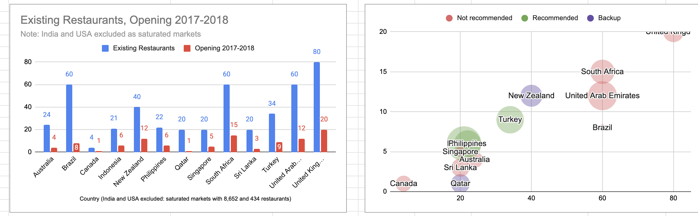
- Description:
The table ranks 13 countries with an Opportunity Score. Chart 1 compares the size of each market with its recent openings. The bubble chart shows quality (height), competition (left to right) and engagement (bubble size) together.

Insights:
• Indonesia (score 0.85), the Philippines (0.76) and Turkey (0.65) rank highest.
• Each has 34 or fewer existing restaurants, but customers are engaged (407 to 772 average votes) and satisfied (average ratings of 4.3 to 4.5). Demand is proven but supply is thin.
• Qatar (0.54) and New Zealand (0.53) rank 4th and 5th and are the backups.
• Larger markets such as the UK, UAE and South Africa have 60 to 80 restaurants each, so competition is higher; Brazil and Singapore have low engagement (about 20 and 32 average votes).

Recommendations:
• Open new restaurants in Indonesia, the Philippines and Turkey.
• Keep Qatar and New Zealand as backup markets.
• Avoid India and the USA for this expansion: they are crowded, and India is also a budget-led market.
• Caution: these markets are small (21, 22 and 34 restaurants), so scores should be re-checked as more data becomes available.

Question 2: Come up with the names of States and cities in the suggested countries suitable for opening restaurants.

Solution:

Approach:
• The dataset has no State column (only City and Locality), so states cannot be assigned reliably. The analysis is therefore done at city level, and the suggested cities are given with their country.
• For the three suggested countries, built a city table (sheet 'Q-2 I Subjective') with the number of restaurants (competition), average rating (quality) and average votes (demand) for each of the 15 cities.
• Used the same Opportunity Score as in Question 1 (40% low competition, 30% rating, 30% votes), scaled across these 15 cities.
• Sample-size rule: a city with only 1 restaurant is labelled 'Watchlist', because one restaurant is not enough evidence.
• Verdict tiers: High potential (score 0.6 or higher), Proven market (average votes of 500 or more and rating of 4.2 or more), otherwise Low priority.
• Charts: a bubble chart (competition vs quality) and a ranked bar chart of city scores.

Charts & Tables:
- Table / Chart Name:
Table: City Opportunity Table (City, Restaurants, Avg Rating, Verdict, Avg Votes) and city score ranking
Chart 1: City Opportunity Map: Competition vs Quality
Chart 2: City Opportunity Score (Higher=better)
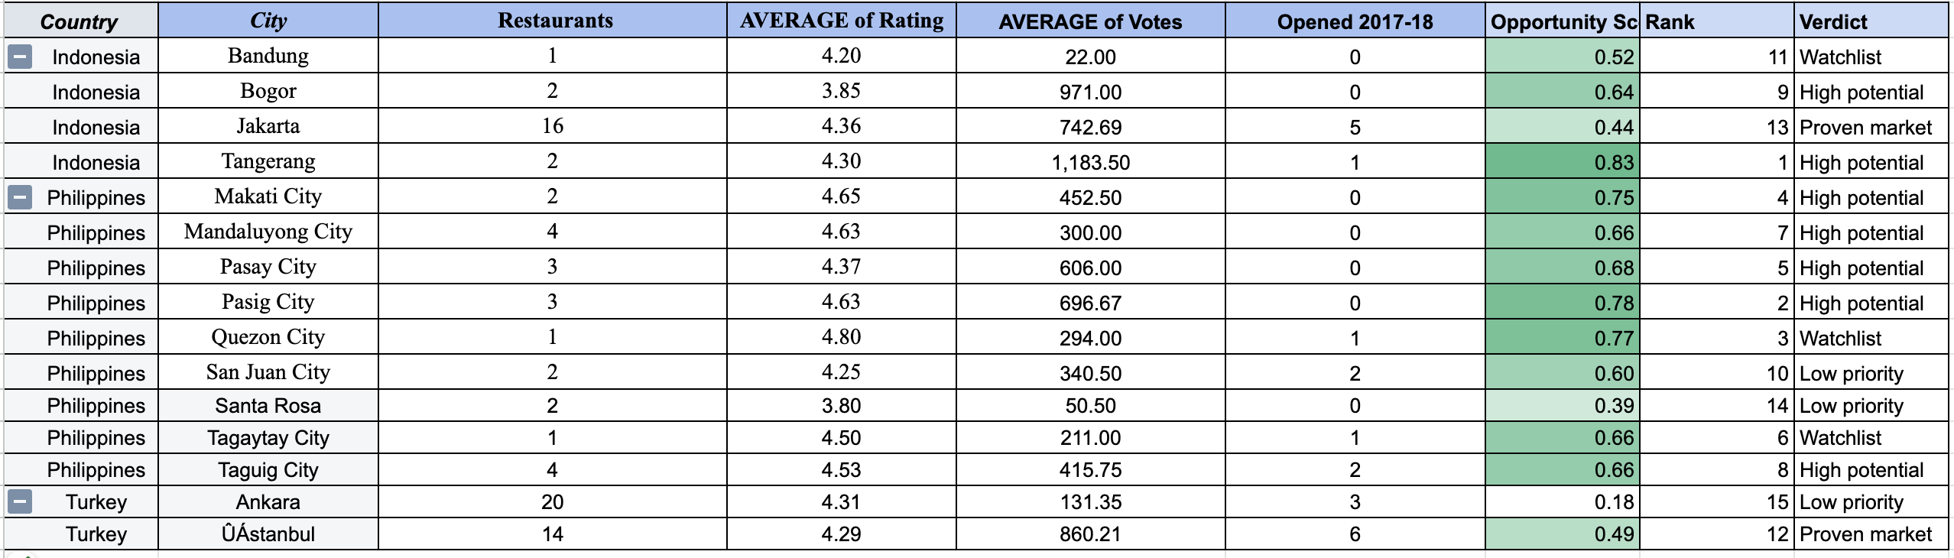
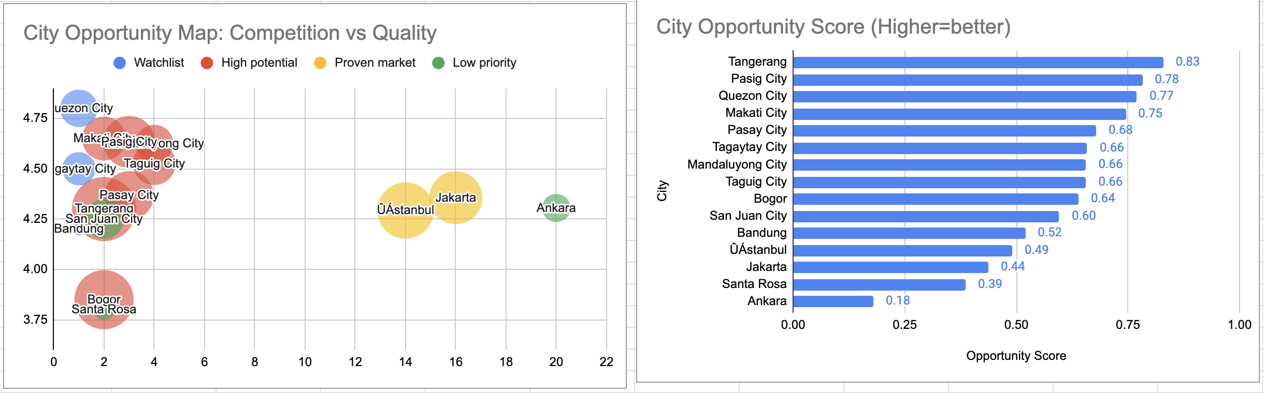
- Description:
Ranks the cities of the three suggested countries. The bubble chart shows which cities have few restaurants but high quality; the bar chart ranks them by score.

Insights:
• Indonesia: Tangerang (score 0.83) has the highest engagement (1,184 average votes) with only 2 restaurants. Jakarta is the proven anchor market (16 restaurants, 4.36 rating, 743 votes) but with higher competition. Bogor (0.64) has high engagement (971 votes) but a weak 3.85 rating, which leaves room for a better restaurant.
• Philippines: Pasig City (0.78), Makati City (0.75), Pasay City (0.68), Mandaluyong City and Taguig City (0.66 each). All have only 2 to 4 restaurants and ratings of 4.4 to 4.65, so Metro Manila is a cluster of opportunity.
• Turkey: Istanbul has 14 restaurants and 860 average votes, against Ankara's 20 restaurants and only 131 votes.

Recommendations:
• Indonesia: open in Tangerang first, use Jakarta as the anchor market, and consider Bogor as a quality-led entry.
• Philippines: start in Pasig City and Makati City, then expand within Metro Manila (Pasay City, Mandaluyong City, Taguig City).
• Turkey: choose Istanbul over Ankara.
• Cities with only 1 restaurant are watchlist only, not recommended yet.

Question 3: According to the countries you suggested, what is the current quality regarding ratings for restaurants that are open there?

Solution:

Approach:
• Quality is measured with ratings, so for each suggested country the table (sheet 'Q-3 I Subjective') shows the number of restaurants, the average rating and the median rating (using MEDIAN with FILTER).
• Restaurants were also grouped into rating brackets 1-2, 2-3, 3-4 and 4-5 with COUNTIFS, and the share of restaurants in each bracket was calculated.
• Benchmarks were added for comparison: all countries excluding India, and India alone.
• 'Open' restaurants were taken to mean the restaurants listed in the data.

Charts & Tables:
- Table / Chart Name:
Table: Rating quality by country (restaurants, average, median, rating brackets, benchmarks)
Chart 1: Average Restaurant Rating: Suggested Countries vs Benchmarks
Chart 2: Share of Restaurants by Rating Bracket
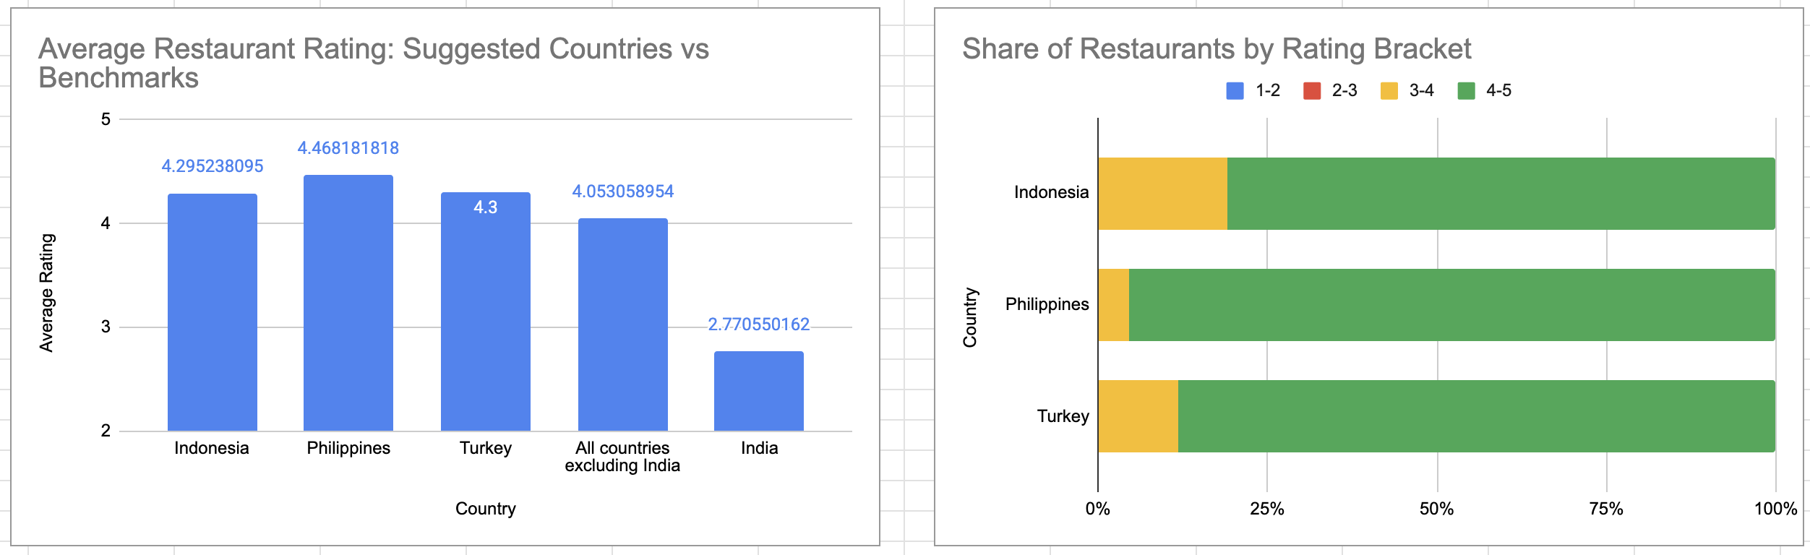
- Description:
The first chart compares the average rating of each suggested country with the benchmarks. The second shows how restaurants are spread across rating brackets.

Insights:
• The Philippines has the best average rating (4.47, with 95% of restaurants rated 4 or above), followed by Indonesia (4.30, 81%) and Turkey (4.30, 88%).
• All three are above the 4.05 average of all other countries excluding India, and far above India (2.77). India's average is also pulled down by about 2,100 restaurants with a placeholder rating of 1.0 (3.35 without them), which does not change the conclusion.
• No restaurant in these countries is rated below 3.4, so the 1-2 and 2-3 brackets are empty.

Recommendations:
• Customers already expect good quality, so a new restaurant must aim for about 4.3 or better.
• The opportunity comes from low restaurant counts and strong demand, not from weak competitors.

Question 4: Also, what is the current expenditure on food in the suggested countries, so we can keep our financial expenditure in control?

Solution:

Approach:
• Food expenditure is measured with Average_Cost_for_two (cost of a meal for two). The costs are in different local currencies, so they cannot be compared directly.
• Converted every cost to Indian rupees (INR): Avg cost (INR) = Avg cost in local currency / local units per 1 USD x INR per 1 USD. The exchange rates (68.4 INR, 14,200 IDR, 52.7 PHP and 4.8 TRY per USD) are approximate 2018 averages kept in editable cells, so they can be updated.
• Table 1 (sheet 'Q-4 I Subjective') shows restaurants, average, median, minimum and maximum cost for each suggested country, plus the INR average.
• Table 2 compares average cost by price range (2, 3 and 4) in INR so that countries are compared like for like.
• The Philippines currency is mislabelled in the data as 'Botswana Pula(P)'; it was treated as the Philippine peso (PHP).

Charts & Tables:
- Table / Chart Name:
Table 1: Average cost for two by country (local currency and INR)
Table 2: Average cost for two by price range (INR)
Chart 1: Avg Cost for Two by Country (INR)
Chart 2: Average Cost for Two by Price Range (INR)
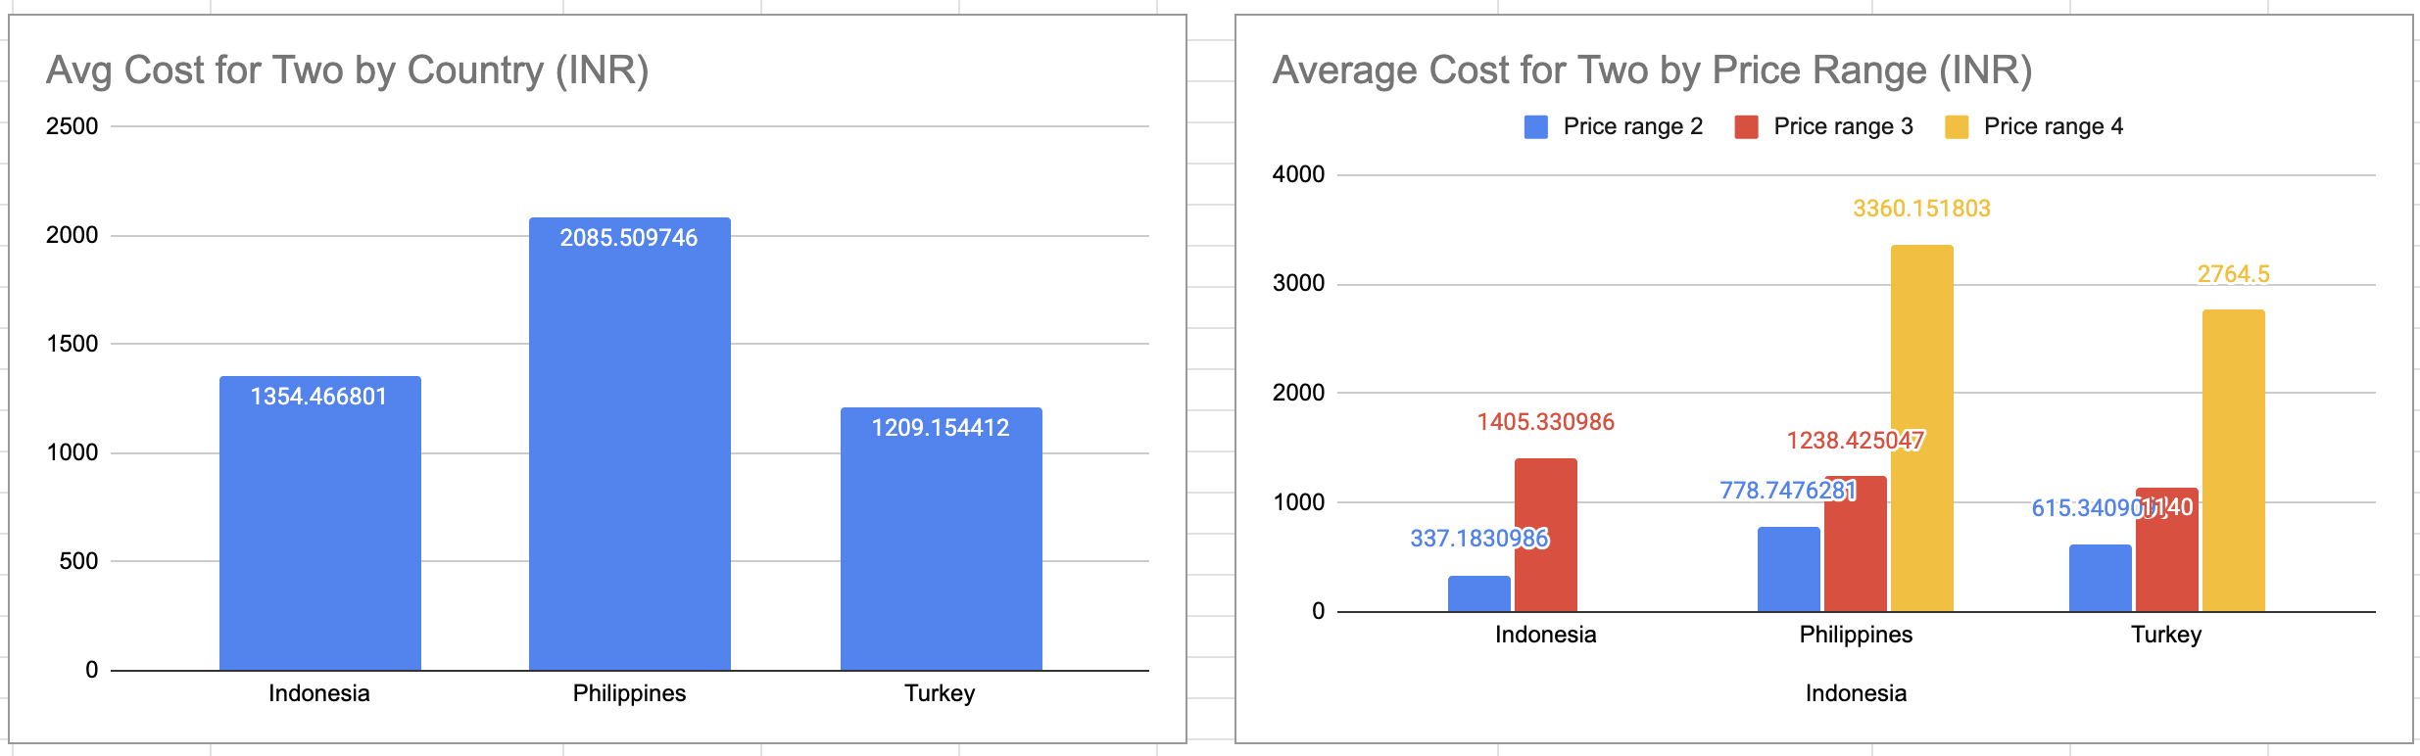
- Description:
Table 1 and Chart 1 show the typical meal cost in each suggested country in a common currency. Table 2 and Chart 2 show what a meal costs within each price range.

Insights:
• Turkey is the cheapest at about INR 1,210, Indonesia is next at about INR 1,350 (12% higher), and the Philippines is the most expensive at about INR 2,090 (roughly 72% more than Turkey).
• Indonesia's restaurants are almost all in price range 3 (20 of 21), while the Philippines has 9 of 22 in the premium range 4.
• At the same price range, costs are close but not equal. In range 3, a meal for two costs about INR 1,140 in Turkey, INR 1,240 in the Philippines and INR 1,405 in Indonesia. In range 4, Turkey costs about INR 2,765 against INR 3,360 in the Philippines.

Recommendations:
• Turkey is the lowest-cost market and has the widest spread of price ranges, so it gives the most room to adjust pricing.
• Indonesia is a mid-cost market concentrated in range 3.
• The Philippines needs the largest budget, especially for premium range 4 restaurants.
• The exchange rates are assumptions; update them before using the INR figures for budgeting.

Question 5: Come up with the names of restaurants from the recommended states that are our biggest competitors and also those that are rated in the lower brackets, i.e. 1-2 or 2-3.

Solution:

Approach:
• 'Recommended cities' are the nine cities from Question 2: Jakarta, Tangerang, Bogor, Pasig City, Makati City, Pasay City, Mandaluyong City, Taguig City and Istanbul.
• Biggest competitors = restaurants with the most votes in those cities. Votes measure customer reach and popularity, so they show who is winning customers; rating is used to break ties.
• Pulled the restaurants of these cities from Cleaned Data with FILTER, matched cities with MATCH, and sorted them with SORT (by votes for competitors, by rating for the weakest).
• Lower brackets: counted restaurants rated 1-2 and 2-3 in these cities (none), then listed the lowest-rated restaurants below 4 as the weakest competitors.
• For the backup market (New Zealand) the lowest-rated restaurant was also checked.

Charts & Tables:
- Table / Chart Name:
Table: Top competitors by votes (name, city, country, cuisines, rating, votes)
Table: Lowest-rated restaurants in the recommended cities
Chart: Top 10 Competitors by Votes (Recommended Cities)
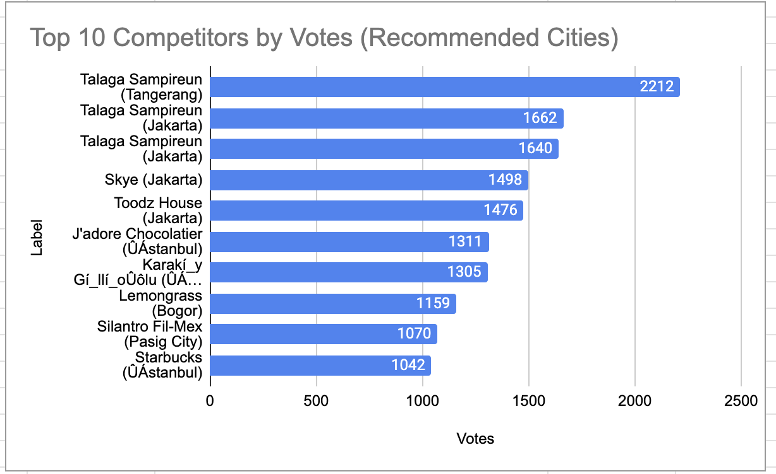
- Description:
The chart ranks the ten most-voted restaurants in the recommended cities. The tables list the strongest and the weakest competitors.

Insights:
• Talaga Sampireun, a 4.9-rated chain with three branches (Tangerang 2,212 votes, Jakarta 1,662 and 1,640), is the clearest threat.
• Next are Skye (Jakarta, 1,498 votes), Toodz House (Jakarta, 1,476), J'adore Chocolatier and Starbucks (Istanbul), Lemongrass (Bogor) and Silantro Fil-Mex (Pasig, 4.9).
• No restaurant in these cities is rated 1-2 or 2-3; the lowest rating is 3.4.
• The weakest competitors, all rated below 4, are Fish Streat (Jakarta, 3.4), Onokabe (Tangerang), Leman Kültür, Huqqa (Istanbul), Momo Milk (Bogor) and OJJU (Jakarta).
• In the backup market, Auckland's De Fontein Belgian Beer Cafe is rated 2.3.

Recommendations:
• Benchmark service and food quality against the top-voted restaurants, especially Talaga Sampireun in Indonesia.
• Target customers of the weaker restaurants (rated below 4); they are the easiest to beat on quality.
• Plan for strong competition in Jakarta and Istanbul, where the most-voted restaurants are located.

Question 6: Which cuisines should we focus on in the newer restaurants to get better feedback? Does the choice of cuisines affect the restaurant ratings?

Solution:

Approach:
• Each restaurant lists several cuisines separated by commas, so a restaurant was counted once for every cuisine it serves. Matching used SEARCH on the text ", cuisine,", which avoids partial matches.
• Analysis is limited to the three suggested countries (77 restaurants, 39 different cuisines).
• For every cuisine: number of restaurants, average rating and average votes (SUMPRODUCT formulas).
• Only cuisines with at least 3 restaurants are charted, because a rating based on 1 or 2 restaurants is not reliable. Highest and lowest lists use cuisines with 8 or more restaurants.
• To answer 'does cuisine affect ratings?', compared the spread between the best and worst cuisines (with 8+ restaurants).

Charts & Tables:
- Table / Chart Name:
Table: Cuisine summary (restaurants, average rating, average votes) with highest/lowest lists
Chart: Average Rating by Cuisine (Cuisines with 3+ Restaurants)
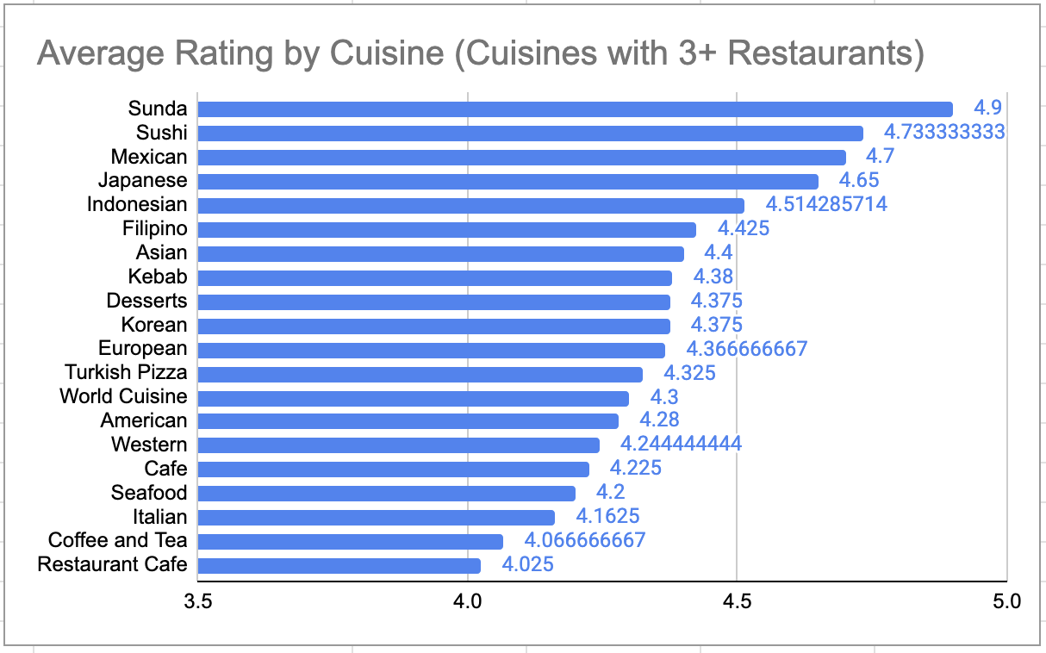
- Description:
The chart ranks cuisines by average rating; the table shows how many restaurants and votes support each result.

Insights:
• Japanese is the strongest proven choice: 8 restaurants, average rating 4.65 and 484 votes. Sushi (4.73) and Mexican (4.70) also score highly but each has only 3 restaurants.
• Indonesian/Sunda cuisine rates 4.51 with the highest engagement (1,311 votes). Filipino (4.42, 8 restaurants) suits the Philippines, and Desserts (4.38, 12 restaurants, 615 votes) is strong in both rating and engagement.
• Cafes are the most crowded cuisine (16 restaurants) and rate only 4.22; Italian rates 4.16 with 8 restaurants.
• Cuisine affects ratings moderately: among cuisines with 8+ restaurants, the best (Japanese, 4.65) is 0.49 points above the lowest (Italian, 4.16).

Recommendations:
• Focus on Japanese/Sushi, Indonesian (in Indonesia), Filipino (in the Philippines) and Desserts.
• Be cautious with Cafe and Italian concepts.
• Caveat: with only 77 restaurants some cuisines rest on 3 restaurants, and the Sunda result is three branches of one chain (Talaga Sampireun), so treat it as one brand's success.

Question 7: According to our current data, should we go for online delivery and table booking? Does that affect the customer’s ratings?

Solution:

Approach:
• Compared average ratings of restaurants with and without each service, using COUNTIFS and AVERAGEIFS (sheet 'Q-7 I Subjective').
• Effect-on-ratings tables: for the suggested countries, India and the other countries, the number of restaurants and the average rating with and without table booking and online delivery, plus the difference.
• India is shown separately because its ratings are much lower overall and it holds 90% of the data.
• Price-range table: the same comparison inside each price range (2, 3, 4, excluding India), to check that the gap is not simply caused by table-booking restaurants being more expensive.
• Checked how many restaurants in the suggested countries actually offer each service.

Charts & Tables:
- Table / Chart Name:
Tables: Effect on ratings by market; table booking and rating at the same price range (excluding India)
Chart 1: Avg Rating With vs Without Table Booking, by Price Range (Excl. India)
Chart 2: Avg Rating With vs Without Online Delivery
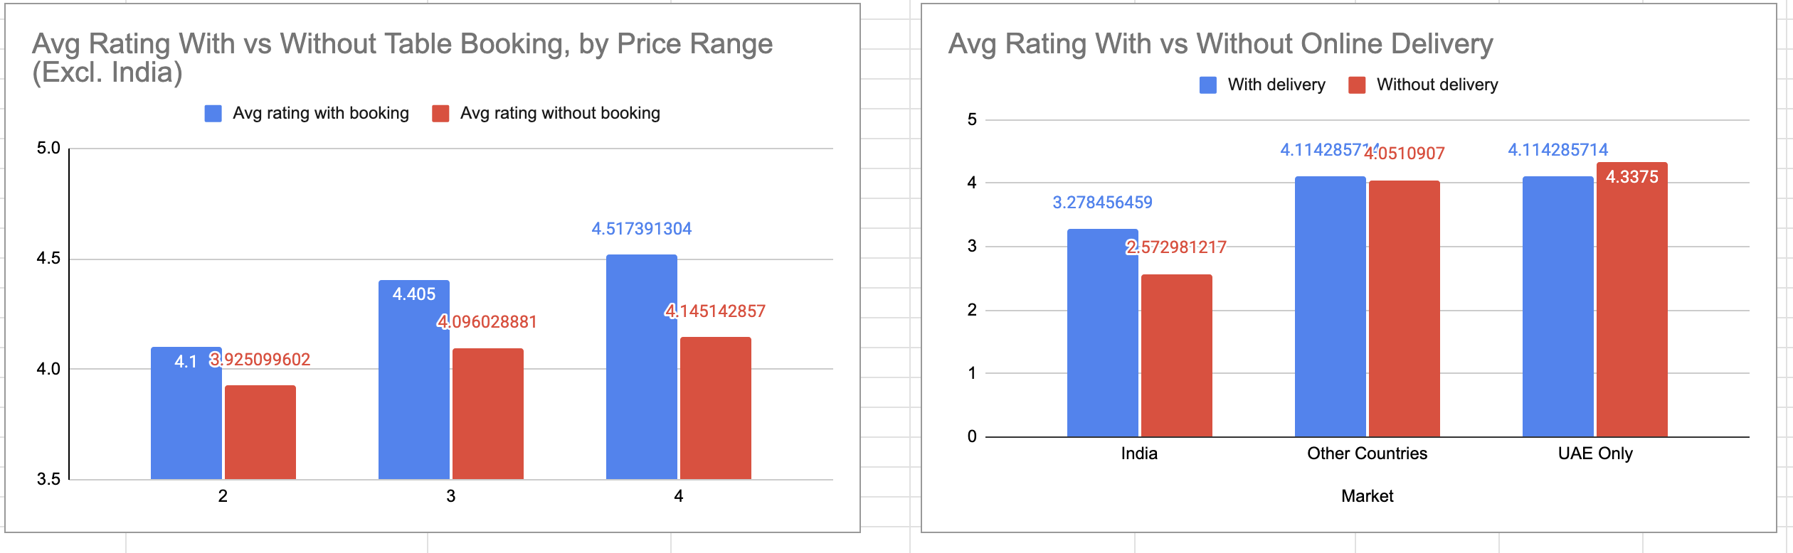
- Description:
Chart 1 compares ratings with and without table booking at each price range. Chart 2 compares ratings with and without online delivery by market.

Insights:
• Restaurants offering table booking are rated higher: 4.43 vs 4.03 outside India, and the gap holds at the same price level (price range 3: 4.40 vs 4.10; price range 4: 4.52 vs 4.15). In the Philippines, booking restaurants average 4.49 vs 4.42 without.
• None of the 55 restaurants in Indonesia and Turkey offer table booking today.
• None of the 77 restaurants in the suggested countries offers online delivery, so the data cannot show its effect there. In India delivery restaurants rate higher (3.28 vs 2.57); in the UAE, the only other market with delivery, they rate lower (4.11 vs 4.34).

Recommendations:
• Table booking: yes. Launch with it; it could also be a point of difference in Indonesia and Turkey.
• Online delivery: do not make it a launch priority. Launch with dine-in plus table booking and trial delivery later.
• Caveat: these are associations, not proof of cause. Table-booking restaurants tend to have higher prices, and only 47 restaurants outside India offer booking.

Question 8: Should the team keep the rate of cuisines higher? Will that affect the feedback? According to our data are the rates of cuisines and ratings, correlated?

Solution:

Approach:
• 'Rate of cuisines' was read as the average cost for two, so the question is whether higher prices go with higher ratings.
• Measured the correlation (CORREL, from -1 to +1) between cost and rating for each suggested country, and between price range and rating for the three countries together (price range is comparable across currencies, cost is not).
• Benchmarks: all non-India countries, and India. A value between -0.2 and +0.2 is read as almost no relationship.
• Table C compares average rating by price range for the suggested countries and for other markets.

Charts & Tables:
- Table / Chart Name:
Table A: Does a higher price go with a higher rating? (correlations by country)
Table C: Average rating by price range
Chart 1: Correlation between Price and Rating - Suggested Countries
Chart 2: Average Rating by Price Range - Suggested vs Other Markets
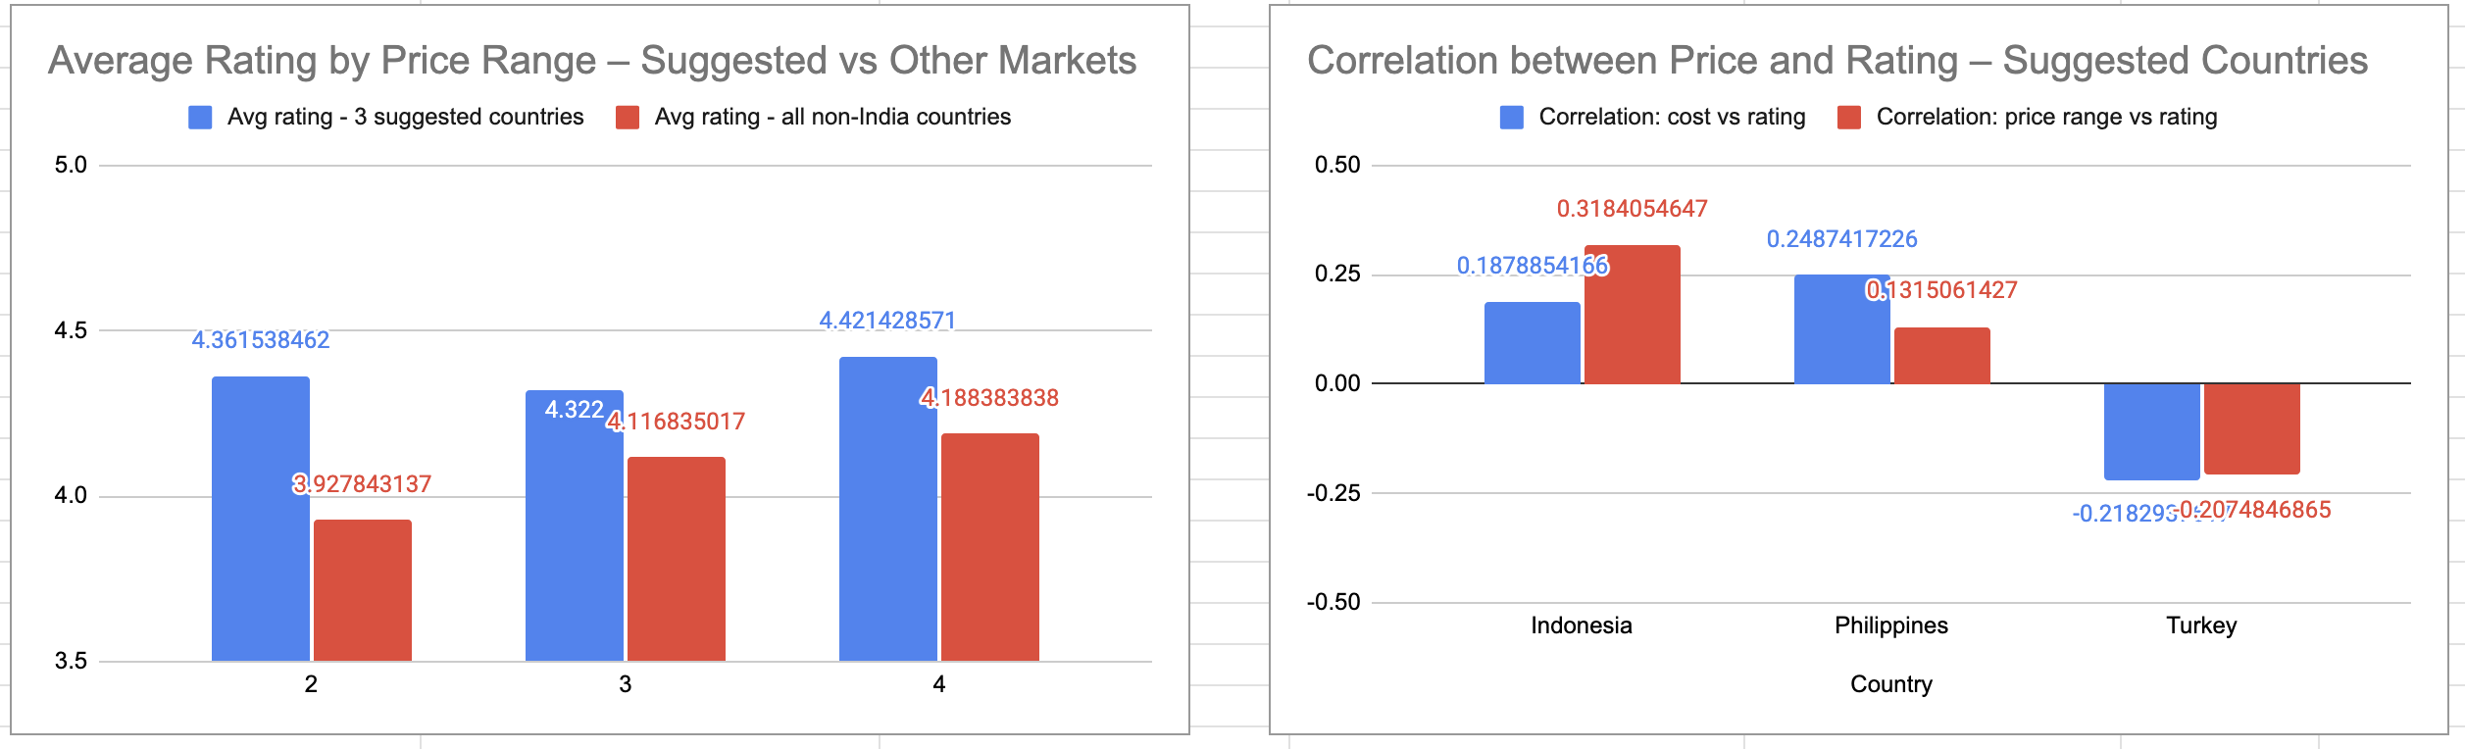
- Description:
Chart 1 shows the correlation in each suggested country. Chart 2 shows average rating at each price range, suggested countries against other markets.

Insights:
• In the suggested countries the correlation between average cost for two and rating is +0.19 (Indonesia), +0.25 (Philippines) and -0.22 (Turkey): weak and not consistent. Pooled by price range it is +0.05, effectively no relationship.
• Average rating is almost identical across price ranges 2, 3 and 4 (4.36, 4.32, 4.42).
• In other non-India markets the link is also weak (+0.18), and ratings rise only modestly with price (3.93 to 4.19). India is the exception (+0.43), but it is not a target market.

Recommendations:
• No, the team does not need to price higher to win better feedback.
• Price for the local market (price range 2 to 3 holds 63 of the 77 restaurants) and compete on service features and cuisine fit rather than premium pricing.
• Caveat: only 77 restaurants, ratings in a narrow band (about 4.2 to 4.5), and correlation does not prove causation, so treat this as a directional finding.

Question 9: What is the distribution of the number of restaurants of different price ranges in all the countries?

Solution:

Approach:
• Counted restaurants for each country and price range (1 to 4) with COUNTIFS (sheet 'Q-9 I Subjective'): Table A = counts, Table B = each country's share in percent, Table C = India vs all other countries.
• Percentages are needed because India has 8,652 restaurants and Canada has 4, so counts alone cannot be compared.
• Chart 1 is a 100% stacked bar of price-range mix by country; Chart 2 compares India with all other countries.
• The result was linked back to the recommended markets.

Charts & Tables:
- Table / Chart Name:
Table A: Number of restaurants by country and price range
Table B: Share of each country's restaurants by price range (%)
Table C: Overall distribution, India vs other countries
Chart 1: Price-Range Mix of Restaurants by Country (% of each country)
Chart 2: Price-Range Mix: India vs Other Countries (%)

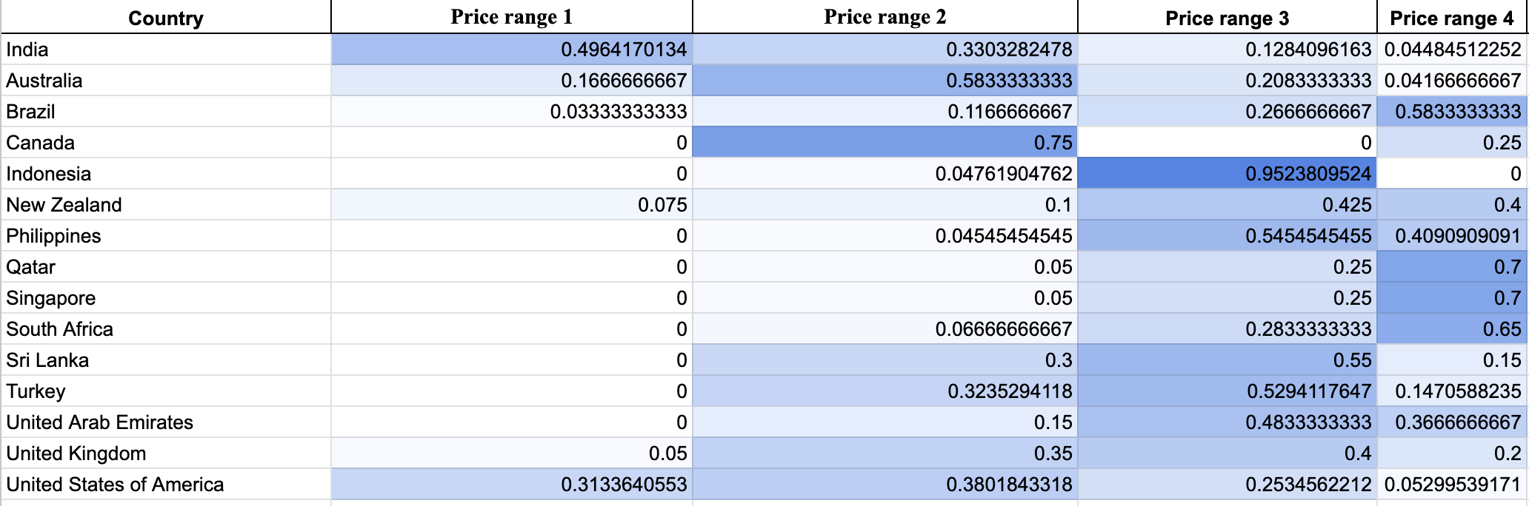
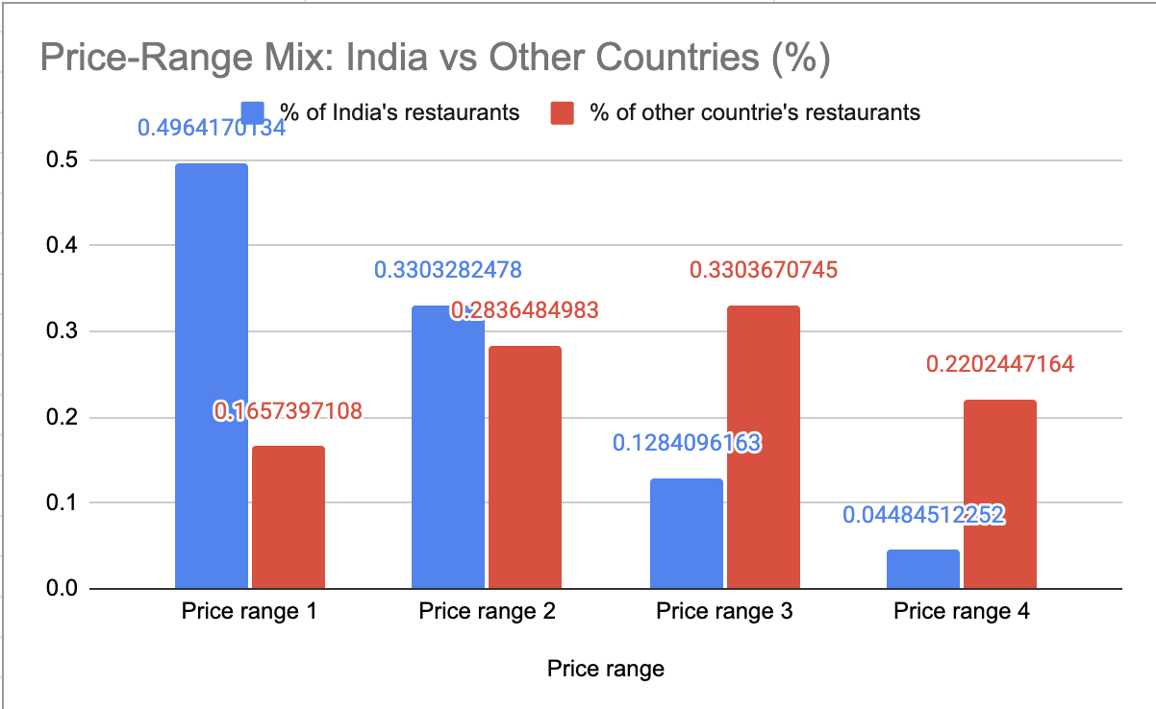
-Description:
The tables give the counts and percentages; Chart 1 shows the mix inside every country and Chart 2 contrasts India with the rest.

Insights:
• Of the 9,551 restaurants, 46.5% (4,444) are in price range 1, 32.6% (3,113) in range 2, 14.7% (1,408) in range 3 and 6.1% (586) in range 4. This is driven by India, which holds 90.6% of all restaurants.
• India is a budget market: 83% of its restaurants are in ranges 1-2 and only 4.5% are premium. In all other countries 55% are in ranges 3-4 and only 16.6% are in range 1.
• Price range 3 is the most common in 7 of the 15 countries (UK, UAE, New Zealand, Turkey, Philippines, Indonesia, Sri Lanka); range 4 in South Africa, Brazil, Qatar and Singapore; range 2 in the USA, Australia and Canada; range 1 only in India.

Recommendations:
• In the suggested countries the market is mid-range: Indonesia has 95% of its restaurants in range 3, the Philippines 95% in ranges 3-4 and Turkey 68% in ranges 3-4, so a mid-range (range 3) restaurant is the safest positioning.
• Qatar and Singapore are already crowded at the premium end (70% in range 4).
• Caveat: Canada (4 restaurants) and Indonesia/Philippines (about 21 each) have small samples, so their percentages are only indicative.

Question 10: Explain your approach in brief for suggesting countries/cities in order to open new restaurants, if the objective and subjective questions would have not been given to assist you. [you have to give bullet pointers in order to answer this question]

Solution:

Approach:
• Define the goal and the measures of success: open where demand is high, customers are satisfied, competition is manageable and costs are affordable. The measures are rating, votes (demand), price range and restaurant count.
• Clean and prepare the data: remove duplicates and blanks, fix date formats and encoding errors, and convert all costs into one currency so countries can be compared.
• Size up each market: count restaurants by country and city to find crowded markets (India, USA) and those with room.
• Check customer satisfaction: average and median ratings and the rating distribution. Strong ratings with many votes show a proven market; low ratings show weak competitors.
• Check affordability and price positioning: average cost in a common currency and the price-range mix, so the restaurant is priced to suit the local market.
• Map the competition: list the biggest competitors (most votes, highest ratings) and the weakest ones (lowest ratings) in each shortlisted city.
• Choose cuisines and services: test which cuisines rate best and whether table booking or online delivery lifts ratings.
• Score and rank: combine competition, rating and demand into one weighted opportunity score, with a minimum sample size so tiny markets do not distort the ranking. Shortlist the top countries and cities.
• Validate and pilot: cross-check the shortlist with outside factors (population, income, rent, regulations), open a small pilot, then monitor results on a dashboard with year and country filters.

Charts & Tables:
- Table / Chart Name:
Not applicable
- Description:
The answer is given as bullet points, as requested.

Insights:
• The same approach produced the recommendations in this report: Indonesia, the Philippines and Turkey as target countries, with Qatar and New Zealand as backups.

Recommendations:
• Re-run the scoring regularly as new restaurant data arrives, and pilot before committing to a full roll-out.

